**Practical No. 3**

1. **Write a program for generating regular expressions**

**for regular grammar (Email Verification)**

1. **Phone Number**

**Code:**

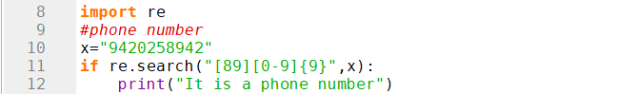

**Output:**

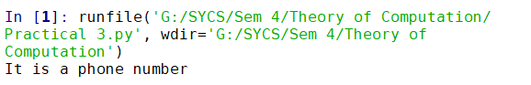

1. **Email ID**

**Code:**

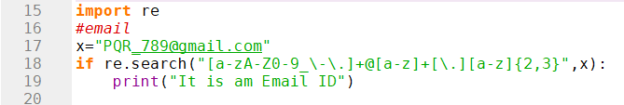

**Output:**

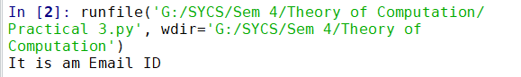

1. **Date**

**Code:**

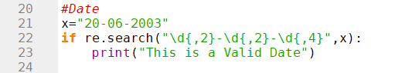

**Output:**

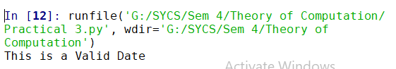

1. **String Validation**

**Code:**

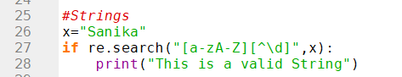

**Output:**

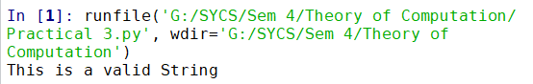

1. **Performing grouped search operations on single statements.**

**Code:**

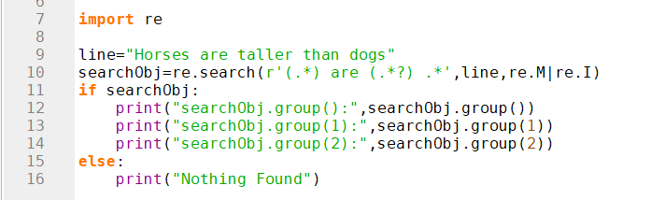

**Output:**

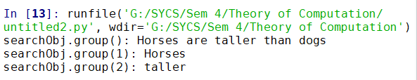

**Code:**

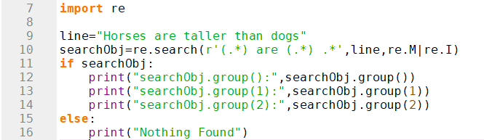

**Output:**

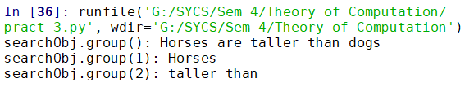

**Code:**

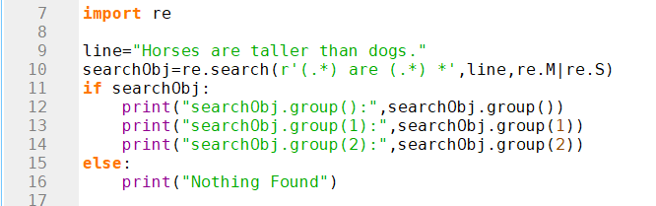

**Output:**

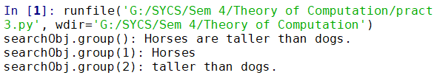

1. **Performing grouped search operations on Multiple**

**statements.**

**Code:**

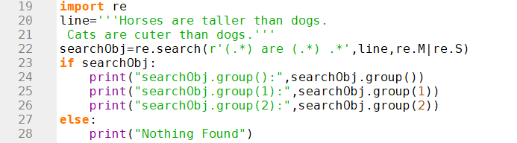

**Output:**

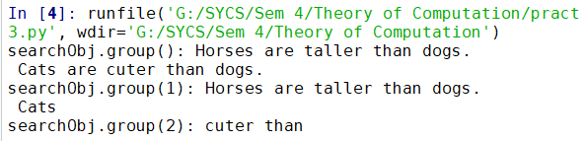

**Code:**

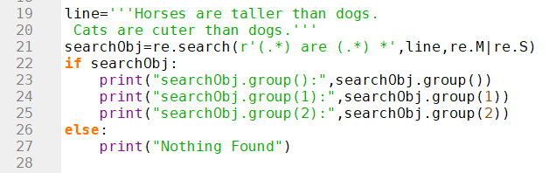

**Output:**

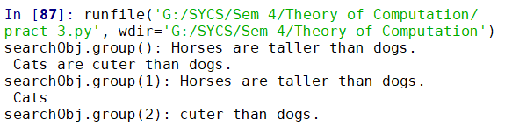

1. **Email Validation**

**Code:**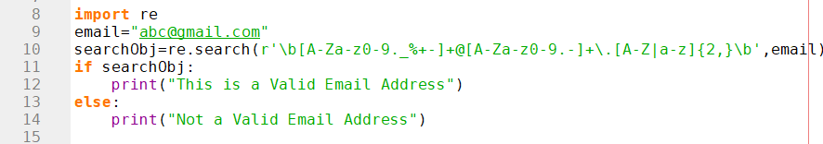

**Output:**

